Innovative furniture for kids

About us
All timkid products are designed to be ergonomic and protect adult backs while offering optimum safety for many different activities for (small) children. Our furniture is known for its functionality and attractive design and also for its durability and ecological selection of materials.
At timkid the egg really did come first: the foundation of the timkid brand was laid in 2000 by a fold-out, wall-mounted changing table called OWO. In the mean time we have expanded our range of changing tables considerably. We have been able to satisfy (almost) every wish as regards to size, shape, colour and material. Over the past years timkid has evolved into one of Europe’s leading manufacturers of wall-mounted changing tables.

Materials
All timkid products fulfil the highest quality requirements.
We develop functional, long-lasting furniture for children, made from ecological materials. Each product must first pass a practical test before it can go into series production. The choice of materials is based on the area of use: we work with high-grade natural wood as well as easy-care HPL. Our skin-friendly changing mats are made of PVC-free PU leather and all other fabrics fulfil Öko-Tex Standard 100 specifications.

Safety
All timkid wall-mounted changing tables are tested by the German Technical Control Board (TÜV) and certified with the GS mark for Tested Safety.
All products with the TÜV seal have been tested for technical safety. In addition, all materials used are subjected to chemical analysis in order to ensure that they are non-toxic and satisfy the strict guidelines for children’s furniture.
We have developed a maintenance-free stopper especially for our wall-mounted changing tables which prevents the flap from falling down unexpectedly. High side sections provide additional support for infants during changing nappies and correspond to accident prevention provision BG/GUV-SR S2.

Ergonomics
Keeping backs healthy is an important factor at timkid.
All timkid products are designed to be ergonomic and protect adult backs while offering optimum safety for the many different activities for (small) children.

Sustainability
Our products are not only durable, but also sustainable.
All furniture and accessories at timkid are made entirely in Germany. We also exclusively use wood from sustainable German forestry. And should any part of our furniture happen to break, we will quickly deliver a replacement.

Functionality
All timkid products are tested by adults and children to ensure that they function as they should.
Babies, children, young people and adults help us to develop functional and long-lasting furniture with an appealing design. With passion and vision, we create children’s furniture that is suitable for every private household. Owing to its robust design, it also satisfies the specific requirements for public locations such as public buildings, hotels, restaurants, museums, libraries, doctors’ surgeries and child day care centres.

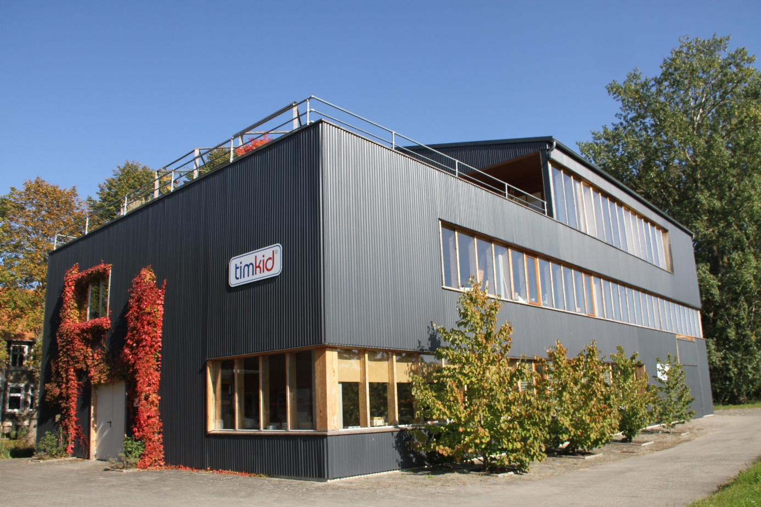

New timkid building 2010
Architect: Jens Peter Frahm

